**Vancouver Foreign Car Control**

**One Way rentals and Drop charges**

The definition of a one way rental is that the drop off location differs from the pickup location. Locations that do not belong to ***Brac Vancouver*** are referred to as a foreign city. Vehicles belonging to franchises other than ***Brac Vancouver*** are referred to as foreign vehicles. The pickup location is referred to as the renting city and the drop off location is referred to as the receiving city.

There are three different one way transactions

* Local one way: Rentals picking up from a  ***Brac Vancouver*** location and are returning to a different  ***Brac Vancouver*** location
* Outbound one way: Rentals picked up from ***Brac Vancouver*** and returning to a foreign city.
* Inbound one way: Rentals picked up at a foreign city and are returning to  ***Brac Vancouver***

**Local One way:**

1. A flat drop charge is applicable on all local one way rentals; this is in order to recoup relocation costs.

**Outbound One way:**

1. The renting location may charge a one way rate or a flat drop charge depending on destination; this is in order to recoup relocation costs.
2. Authorization to drop vehicles at any a foreign city is entirely and solely based on availability and management approval. ***Brac Vancouver*** may not allow one way rentals to all foreign cities, because:
   * Cost of recovering vehicle from certain remote cities may be enormous. (E.g. drop off in Ontario, California etc.)
   * Chances of liability involved in traveling to farther distances due to road conditions or possible claims issues.
3. One way rentals to foreign cities are permitted but only with Managers approval, unless specified on Daily Game Plan. We always prefer to rent a vehicle that belongs to the foreign receiving city, before we use ***Brac Vancouver*** vehicle.
4. Outbound one way traffic is more seasonal business is peaking during summer due to demand and good road conditions.  Demand during winter and shoulder periods weans due to severe road conditions. This is one of the reasons ***Brac Vancouver*** does not allow any one way rentals during this period to the following area BC interior, Alberta, Vancouver Island and USA (other than Seatac Airport).
5. One way rental can be rented using daily rate plus applicable drop charge, shown in GIS or one way rate (First day at higher price including drop charge and additional associated days) if available in GIS. Rates must be approved by location Manager.
6. Foreign Car Control Department be responsible to provide the receiving city and owning city (if they differ) the open contract.
7. Foreign Car Control Department responsible to close the contract once the vehicle reaches the receiving city.
8. If the vehicle belongs to ***Brac Vancouver*** Foreign Car Control Department responsible to follow up with receiving city for the opportunity /reservation to “rent back” vehicle or request the vehicle to moved back home.
9. Unauthorized Drop: If a vehicle returned different city other than agreed city on rental agreement, this it is considered as unauthorized drop; please advise the customer they will incur additional charges. Please advise the foreign car control dept. and note in comments, and do not change the drop location in GIS as this will trigger the authorized drop charge. The unauthorized drop charge is double the authorized drop charge.

**Inbound one ways:**

**Receiving Foreign vehicles**

1. **Lot attendant (Return Lane):** will now be able process Foreign Vehicle Slip using the handheld device for the customer as record of the vehicles return in Vancouver. Vehicle must be inspected and a copy of the gas receipt must be requested as per our inspection process. Please note this is not an official receipt, renters finalized receipt will be provided by the renting location.

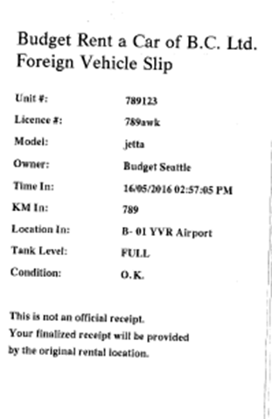

1. **Locations without Handheld**: Please follows below procedures and fill out manual **Check in Form**. Vehicle must be inspected and a copy of the gas receipt must be requested as per our inspection process.

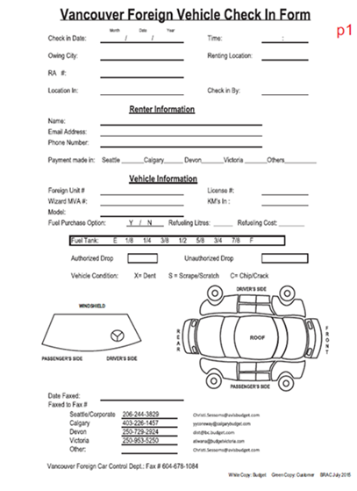

The following information must be completed on **Check in Form**

1. Check In Date & Time
2. Owning City
3. Renting City
4. Ra #
5. Location In
6. Renter Name
7. Unit number
8. Wizard number
9. License plate#
10. Model
11. Color
12. Km In
13. Fuel Level
14. Vehicle Condition
15. Note down any other equipment return with vehicle such as GPS, Baby Seat

Once completed please customer into the front desk with their rental agreement if present.

1. **CSR (Front Desk)**: Please advise the Renter that the Renting City will process all charges and send out a final receipt. Copy of this Manual Check in Form can be given to Renter as temporary receipt. If customer requires a final receipt emailed to them please have them leave an email address on the **Check in Form.**

If renter wants to change method of payment, explain to renter this need to be done by Renting City, we will forward all information to Renting City,

1. Please fax or scan and email completed **Check in Form** to the corresponding renting city at the bottom for the Check in Form.

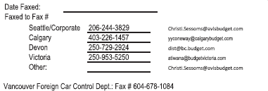

1. If the vehicle processed via handheld closing information can found on Foreign Vehicle Check-In Log foreign/audit department will provide renting city with closing information

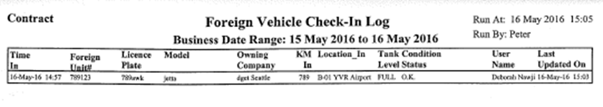

1. If there is claim on inbound foreign vehicle, refer to claims section & process foreign check-in as usual.
2. **Important Steps**

The foreign vehicle must be added to the **fleet** in GIS under **Add foreign vehicle screen**. When adding the foreign vehicle it is imports that under Current Location please select the renting location and for the Current KM please use the outgoing Km from original agreement.

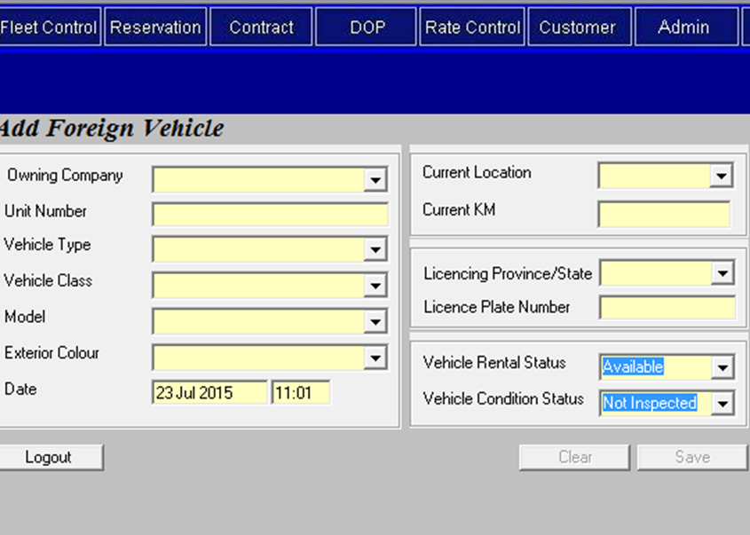

Once vehicle add please complete vehicle movement from the renting city to receiving location. Under Send the **Date out & Time out** should be the renting date & time and **Staring KM** should be the outgoing Km from original agreement.

1. **Under Vehicle Movement Screen comments section** the following must be recorded foreign RA number, customer name check in date, time & fuel level.

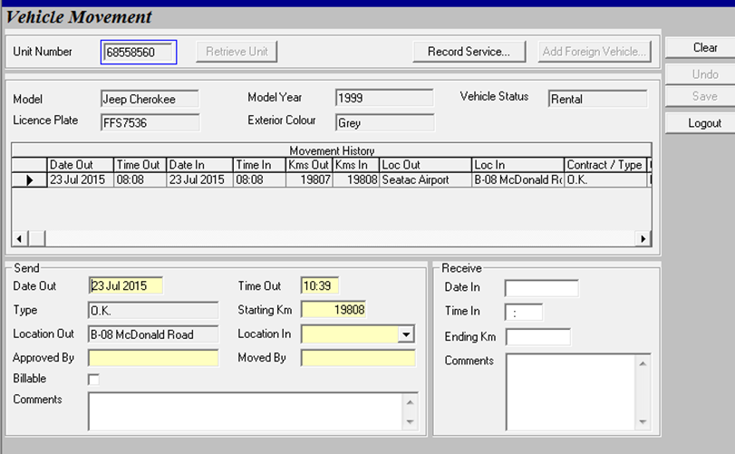

When receiving the vehicle please ensure the **Date in & Time** coincides with the Check in Date & Time.

**Brac Vancouver Vehicle rented from a foreign location**

1. **Lot attendant (return lane):**  may not be able to close the contract in certain cases (rent back contract has not been entered into GIS), the must renter be sent in to the counter with a completed manual **Check in Form.** If an open contact exists in GIS before closing, please ensure the renter information is correct.
2. **CSR (front desk)**: If an open contact exists in GIS, please ensure the renter information is correct before closing . If please open a “ rent back “ (see pg. 13)
3. If there is claim on inbound foreign vehicle, refer to Claims Section.

**In case all of inbound one way rentals, copy of closed contract must be faxed to the renting location.**

**Closing a Foreign Contract**

Use this procedure if you are **checking in a vehicle belonging to a foreign location and rented by a foreign location**.

If you are checking in a vehicle belonging to your location, but rented by a foreign location, please open and *close a* ***Rent Back Contract*.**

The procedure for closing a foreign contract is similar to the one for closing a regular contract.

**STEP 1 Entering the Foreign Contract Information**

1. On the Foreign Check In base screen, use your mouse to drop your cursor in the Foreign Contract # field. Enter the foreign contract number.

2. Return to the first field on the screen and enter the rest of the Contract Information as listed on the foreign contract (date out, time out, and so on).

**STEP 2 On the Check In Vehicle Tab**

3. On the Check In Vehicle tab, enter the vehicle’s Unit #, Model, and License Plate Number.

**NOTE:** If the customer has brought in a different vehicle than the one listed on the contract, enter the information for the vehicle that is presently at your location and make a note of the replacement in the Printed Additional Comments section on the Comments tab.

4. Select the name of the Owning Company from the drop down.

**NOTE**: When entering the Unit #, be sure to enter it exactly as it appears. Do not add or remove anything. GIS will validate the unit you enter against all existing foreign units in the system. If you accidentally enter an incorrect unit number or license plate number, GIS will pop up a screen to confirm your entries, as shown in Figure 6-2, and you can select the correct one. You can close the pop up window if you want to ignore the message.

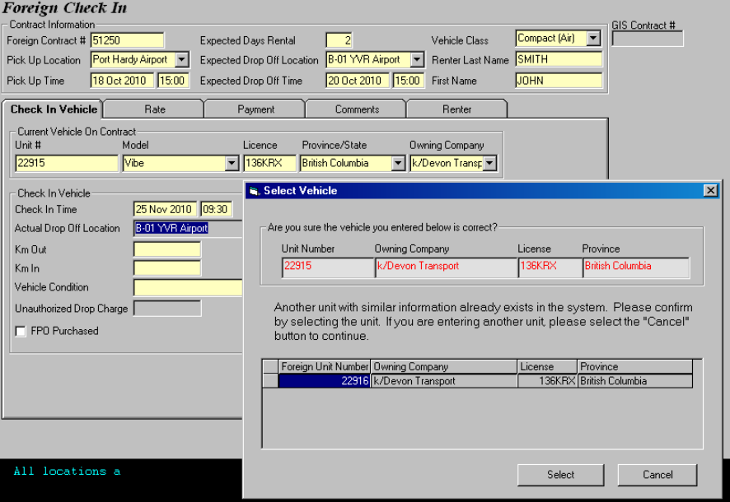

Figure 6-2: The incorrect unit number that was entered is validated in the pop up window.

5. In the Check In Vehicle section, enter the following information:

|  |  |
| --- | --- |
| Check In Time | Defaults to current time. |
| Drop Off Location | Defaults to your location. This field cannot be changed |
| Km Out  Km In | GIS uses these figures to calculate the total number of kilometers driven in the Fuel Information section. |
| Vehicle Condition | Select from the drop down. |
| Unauthorized Drop Charge | GIS does not allow you to make an entry in this box.  If the foreign location asks you to add a Drop Charge, use the Rate Details button on the Rate tab and enter the Drop Charge on the Non-GIS Rate Details screen |

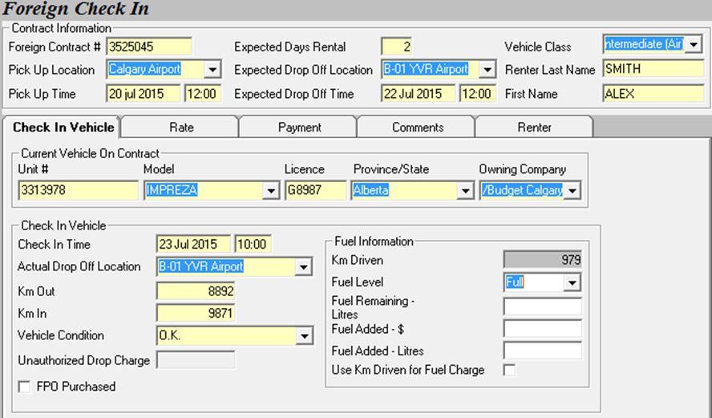

6. If the renter purchased the FPO when the contract was opened, check FPO Purchased and enter the amount in the FPO Charge field. —or— In the Fuel Information section, enter the vehicle’s Fuel Consumption.

|  |
| --- |
| **NOTE** This FPO Charge field only displays if FPO Purchased is selected. If FPO Purchased is not selected, the Fuel Information section displays. |

**STEP 3 On the Rate Tab**

**NOTE** The GIS rate table does not contain foreign rates or unauthorized drop charges. Call the renting location to get the appropriate rate information.

7. On the Rate tab, enter the currency into the Currency field.

8. On the Rate tab, enter applicable taxes into the three fields in the Taxes section. If no taxes apply, enter 0.

**NOTE** Check with your supervisor if you are not sure of the tax rates that apply to the foreign location.

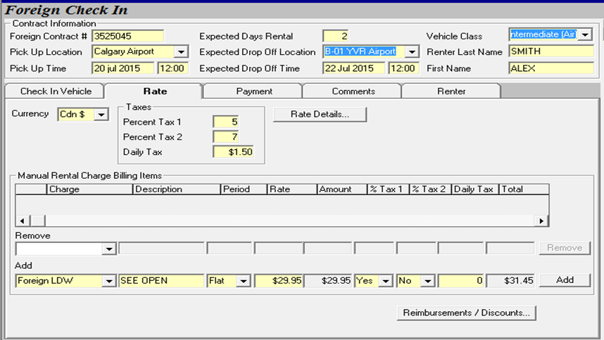

9. Select Rate Details.

**The Non-GIS Rate Details screen appears.**

**NOTE** There are many ways to write a rate, so ensure that you understand the policy of the renting location and make sure that what you are entering makes sense. Use the Comments field to explain anything unusual.

**NOTE** Budget policy requires you to completely fill out all the rate fields hourly as well as daily. (If an hourly rate doesn’t show, divide the daily rate by 3, add 1 cent, and use that.)

**NOTE** This example assumes that the first day rate is $200, each additional day is $50, and an hourly charge of $20 applies for partial days. There is no KM cap.

a. Select a Rate Purpose from the drop down.

b. Enter a descriptive rate name, such as [Name of foreign city] to Vancouver.

c. To enter a first day charge, select Day in the Charges section and enter From = 1, To = 1, and Amount = $200.

d. To enter the charge for additional days, select Day in the Charges section and enter From = 2, To = 9999, and Amount = $50.

e. To enter the hourly charge, select Hour in the Charges section and enter From = 25, To = 9999, and Amount = $20.

f. In the Inclusions section, place a check in the boxes beside any items that are included in the rate. Check with your supervisor if you have any questions.

g. If a drop charge is indicated on rental agreement, please insert amount under the **Drop Off Charge.**

**IMPORTANT** The Inclusions section is new functionality. Please be absolutely certain that the items you check off here are included in the price of the rental. GIS does not calculate charges for the items you mark as Inclusions.

**NOTE** If you select LDW, enter the deductible in the Responsibility field.

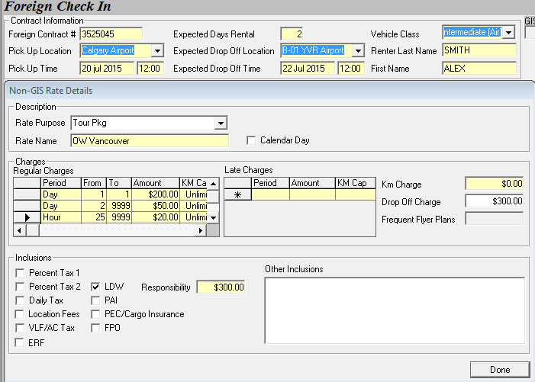

g. Click Close.

**NOTE** Once you have opened the Non-GIS Rate Details screen, you must enter a rate before closing. If you accessed the screen by mistake, enter a “dummy” rate using the Rate Name “Error”, and an Amount of 0. Then click Close. Never shut down the browser in the middle of a transaction. If you need help, ask a colleague or call the Help Desk.

10. In the Manual Rental Charge Billing Items section of the Rate tab, enter any additional charges (including insurance).

a. Use the Add drop down to select the item you want to add.

b. Enter a description, if required.

c. Enter the period the rate is for (Daily, Weekly, or Flat) and then enter the charge. The Total calculates in the field on the far right.

d. Select Yes or No in the appropriate columns to indicate whether Tax 1 and Tax 2 apply to this item. Enter the amount of Daily Tax (PVRT) as well. The Total adjusts to account for these taxes.

e. Click Add.

The item appears on the list above the Add section, along with a Location Fee (service charge) if applicable. GIS calculates this Location Fee itself, according to the policies and rates of the renting location.

f. Use this same procedure to add any other items as necessary.

**NOTE** Remove a manual charge item by selecting it from the Remove drop down and clicking Remove.

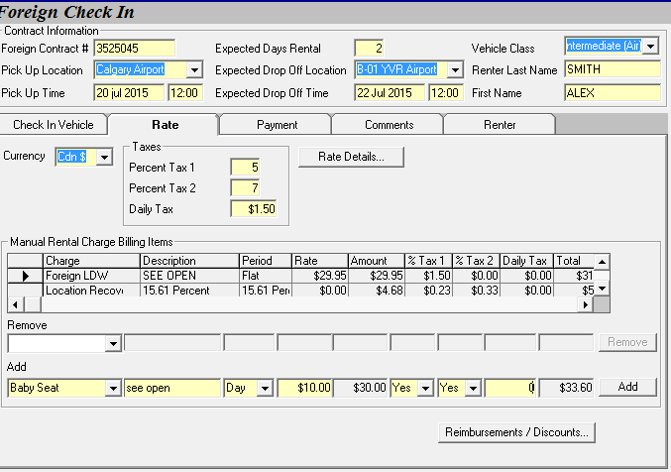

**7.7%**

**STEP 4 on the Payment Tab**

Inform the customer that the outstanding balance will be collected against the credit card used to authorize the rental by the renting location.

**NOTE:** Rent Back contracts like these are to be done by BRAC BC HO **only**

**NOTE** If the customer wants to change payment methods, close the contract by taking payment the same way that you would for any regular contract. See C About Regular Payment Methods.

11. On the Payment tab, click Deposit/Refund Record.

The Deposit Record screen appears.

In the Credit Card Authorizations section, select the name of the foreign location in the Collected At field. The credit card fields turn white and are no longer mandatory.

12. Enter the Amount of the authorization taken by the foreign location in the yellow field at the far right.

13. Click Authorize.

The Manual Credit Card Authorization window appears.

14. Type in the renting location and click Complete.

15. Click OK to return to the Payment tab.

The Amount Already Preauthorized is now entered into the correct field. Continue with the Foreign Contract Close.

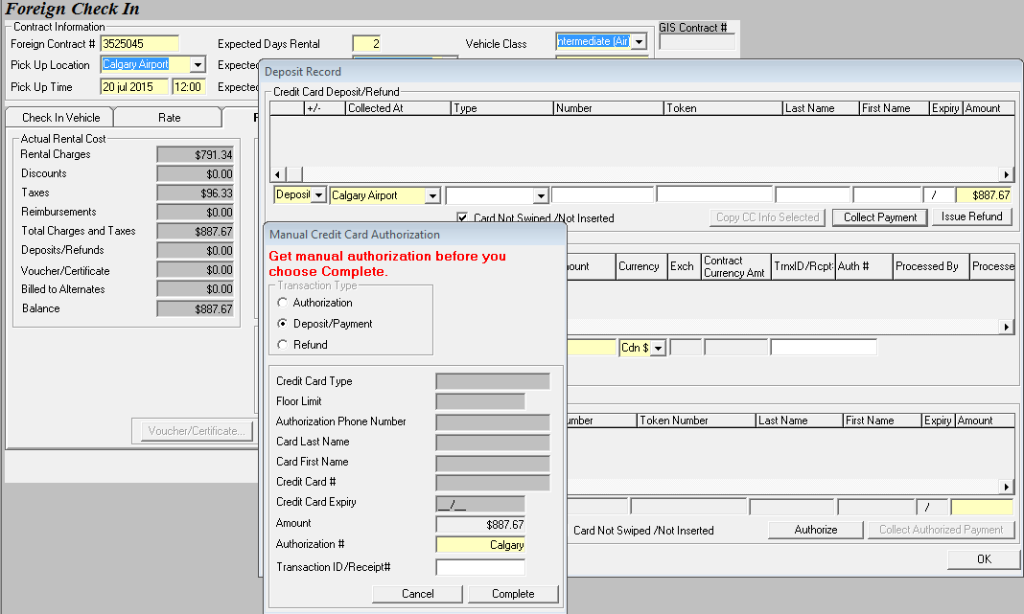

**STEP 5 On the Comments Tab**

16. On the Comments tab, enter any Comments, or transcribe them from the foreign contract.

**STEP 6 On the Renter Tab**

17. All of this information is optional, except for the Renter’s First and Last Name, which was mandatory on the Foreign Check In base screen.

18. Enter Additional Drivers, if necessary.

NOTE No rental charge items are created for additional drivers for Foreign Check In. If you need to add a charge, use Manual Rental Charge Billing Items.

**STEP 7 Completing the Foreign Contract**

19. Choose from among the following options:

* Click Check In to close and save the contract.
* Click Print to print and save a copy of the contract.
* Click Clear to clear the screen without saving changes.

**NOTE** Staple the "Check In Form + Foreign City RA + GIS Foreign Close out" as one complete transaction give to the Inter-branch dept.

**Rent Backs**

“Rent back” is when a foreign location has rented one of Budget’s vehicles and the renter is dropping it off at your location. (In other words, the vehicle is returning home to you.)

The contract needs to be entered into GIS so you can check the vehicle in when it arrives.

When a Budget vehicle is rented from a foreign location, a copy of the contract is emailed to Foreign Car Control Dept. and the relevant information is entered into GIS. This means that usually the contract information you need at check in is entered already. Before you open a new rent back contract, you must ensure that the contract is not already on file.

**To Search for an Existing Rent Back Contract**

1. On the Budget Main Menu bar, click Fleet Control.

The Fleet Control drop down appears.

2. Select Search.

The Search drop down appears.

3. Select Single Vehicle Search.

The Single Vehicle Search window appears.

4. Enter the vehicle’s unit number or plate number from the key tag into the appropriate field.

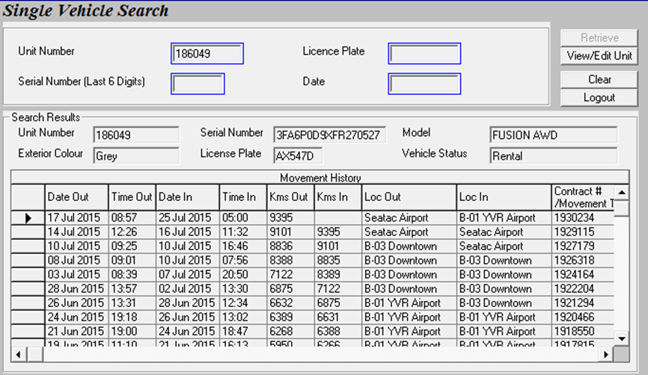

5. Click Retrieve.

The Search Results section displays recent and unfinished contracts for the vehicle.

6. Review the list, looking for blanks in the Kms In column that show the vehicle has not been checked in.

|  |
| --- |
| **NOTE** Ensure that you are not selecting the entry that shows the vehicle leaving your location, since the foreign location that checked in the vehicle may not have forwarded the paperwork yet. |

**Opening a Rent Back Contract**

The Foreign Car Control Dept. usually receives email notification of rent back contracts from the foreign location in time to enter them for you. However, if they don’t get the information in time, you may need to open the rent back contract yourself.

**NOTE** before you do anything to open a rent back contact, please ensure that the contract is not already on file by using the vehicle search procedure.

The procedure for opening a rent back contract is similar to the one for opening a regular contract. The major difference is that you do not have to take down the customer’s payment information, since the foreign location is charging the customer. However, you do have to record the payment rate stated in the original contract.

**STEP 1. Select Contract Open/Check Out**.

**STEP 2. Identifying the Location as Foreign**

1. In the Pick Up Location drop down, select the name of the foreign location that rented the vehicle.

GIS automatically updates the Contract Open/Check out screen to display the Rent Back functionality.

2. Be sure to enter the Foreign Contract number into the field on the right hand side of the screen.

**STEP 3. On the Renter Tab**

3. On the Renter tab, enter the Renter’s Last Name & First Name.

4. Enter any Additional Drivers.

5. On the Check-out Vehicle section of the Renter screen, enter the Unit # and the License from the foreign contract.

6. Click Get Vehicle to retrieve the information for the Unit # you entered.

7. If contact indicates that a FPO has been purchased please click on FPO and enter flat rate

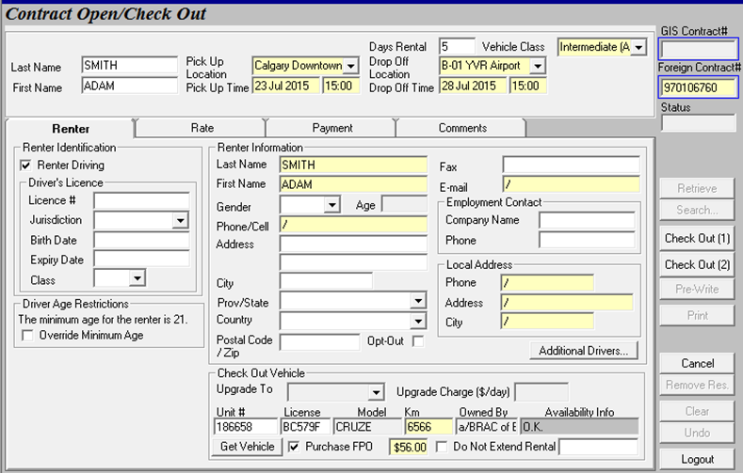

**STEP 4. On the Rate Tab**

8. On the Rate tab, enter the currency into the Currency field.

9. On the Rate tab, enter applicable taxes into the three fields in the Taxes section. If no taxes apply, enter 0.

**NOTE** Check with your supervisor if you are not sure of the tax rates that apply to the foreign location.

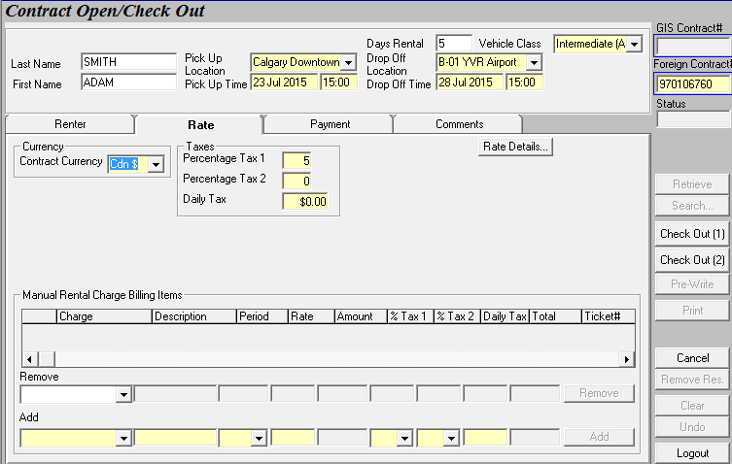

10. Select Rate Details.

**The Non-GIS Rate Details screen appears.**

**NOTE** There are many ways to write a rate, so ensure that you understand the policy of the renting location and make sure that what you are entering makes sense. Use the Comments field to explain anything unusual.

**NOTE** Budget policy requires you to completely fill out all the rate fields hourly as well as daily. (If an hourly rate doesn’t show, divide the daily rate by 3, add 1 cent, and use that.)

**NOTE** This example assumes that the first day rate is $299.99, each additional day is $99.95, weekly rate is $799.99 and an hourly charge of $50.01 applies for partial days. There is no KM cap.

a. Select a Rate Purpose from the drop down.

b. Enter a descriptive rate name, such as [Name of foreign city] to Vancouver.

c. To enter a first day charge, select Day in the Charges section and enter From = 1, To = 1, and Amount = $299.99

d. To enter the charge for additional days, select Day in the Charges section and enter From = 2, To = 9999, and Amount = $99.95

e. To enter the charge for weekly rate, select Weekly in the Charges section and enter From = 1, To = 9999, and Amount = $799.99

f. To enter the hourly charge, select Hour in the Charges section and enter From = 25, To = 9999, and Amount = $50.01

g. In the Inclusions section, place a check in the boxes beside any items that are included in the rate. Check with your supervisor if you have any questions.

h. If a drop charge is indicated on rental agreement, please insert amount under the **Drop Off Charge**.

**IMPORTANT** The Inclusions section is new functionality. Please be absolutely certain that the items you check off here are included in the price of the rental. GIS does not calculate charges for the items you mark as Inclusions.

**NOTE** If you select LDW, enter the deductible in the Responsibility field

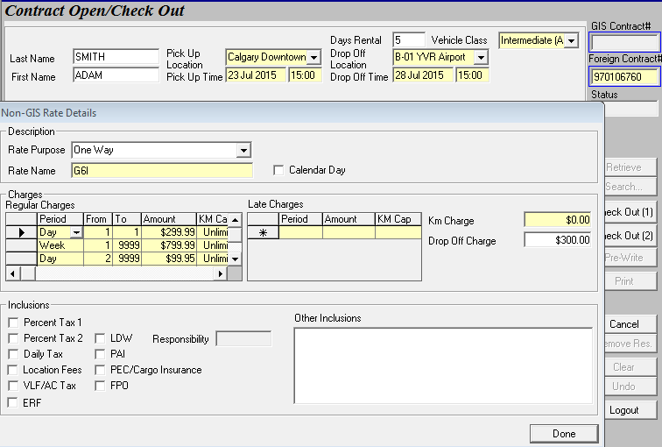

g. Click Close.

**NOTE** Once you have opened the Non-GIS Rate Details screen, you must enter a rate before closing. If you accessed the screen by mistake, enter a “dummy” rate using the Rate Name “Error”, and an Amount of 0. Then click Close. Never shut down the browser in the middle of a transaction. If you need help, ask a colleague or call the Help Desk.

11. In the Manual Rental Charge Billing Items section of the Rate tab, enter any additional charges (including insurance ).

a. Use the Add drop down to select the item you want to add.

b. Enter a description, if required.

c. Enter the period the rate is for (Daily, Weekly, or Flat) and then enter the charge. The Total calculates in the field on the far right.

d. Select Yes or No in the appropriate columns to indicate whether Tax 1 and Tax 2 apply to this item. Enter the amount of Daily Tax (PVRT) as well. The Total adjusts to account for these taxes.

e. Click Add.

The item appears on the list above the Add section, along with a Location Fee (service charge) if applicable. GIS calculates this Location Fee itself, according to the policies and rates of the renting location.

f. Use this same procedure to add any other items as necessary.

**NOTE** Remove a manual charge item by selecting it from the Remove drop down and clicking Remove

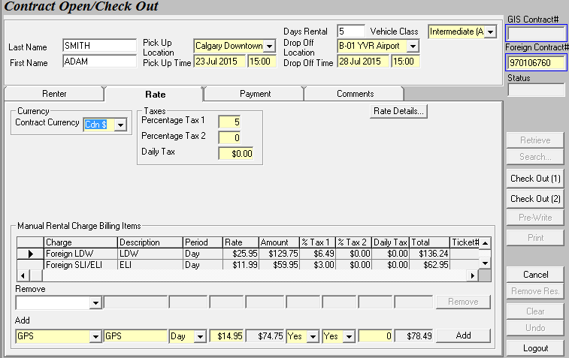

**STEP 5 On the Payment Tab**

Inform the customer that the outstanding balance will be collected against the credit card used to authorize the rental by the renting location.

**NOTE:** Rent Back contracts like these are to be done by BRAC BC HO **only**.

In the Payment tab’s credit card fields will be grayed out in these situations. This is because the renting location is always the one to collect the money. **To be implemented**.

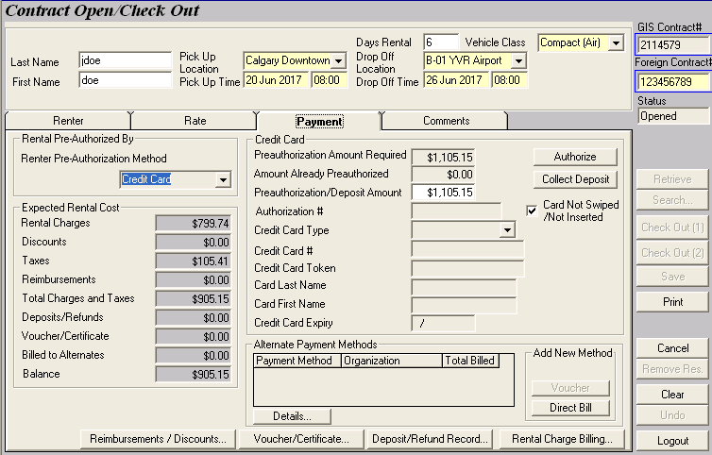

**NOTE** If the customer wants to change payment methods, close the contract by taking payment the same way that you would for any regular contract. See C About Regular Payment Methods.

11. On the Payment tab, click Deposit/Refund Record.

The Deposit Record screen appears.

In the Credit Card Authorizations section, select the name of the foreign location in the Collected At field. The credit card fields turn white and are no longer mandatory.

12. Enter the Amount of the authorization taken by the foreign location in the yellow field at the far right.

13. Click Authorize.

The Manual Credit Card Authorization window appears.

14. Type in the renting location and click Complete.

15. Click OK to return to the Payment tab.

The Amount Already Preauthorized is now entered into the correct field. Continue with the Foreign Contract Close

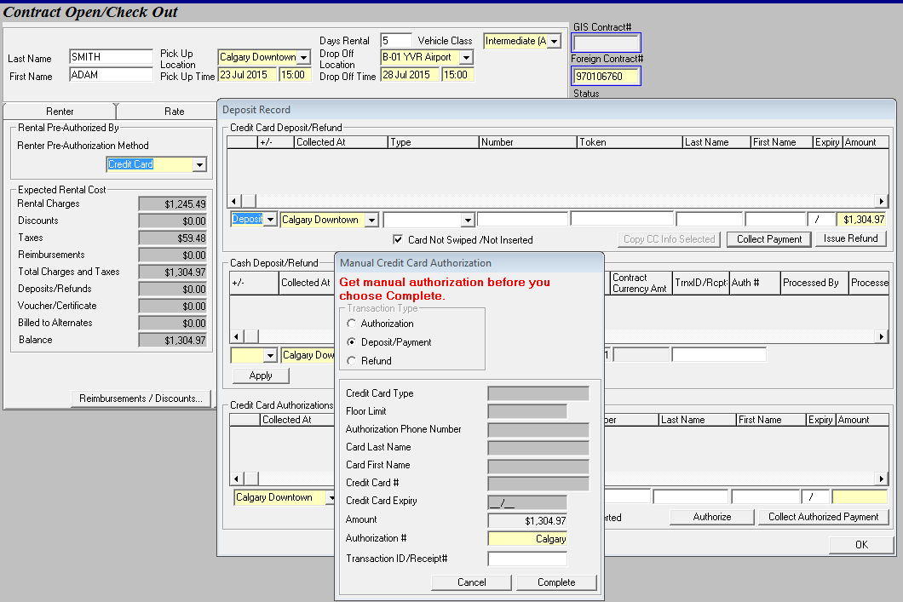

**STEP 6 On the Comments Tab**

16. On the Comments tab, enter any Comments, or transcribe them from the contract.

**STEP 7 Completing the Rent Back Contract**

19. Choose from among the following options:

* Click Check In to close and save the contract.
* Click Print to print and save a copy of the contract.
* Click Clear to clear the screen without saving changes.

**NOTE** Staple the “Foreign City RA + GIS Open “as one complete transaction and give to the Inter-branch dept.

**Foreign Vehicle Exchange**

Foreign Vechicle exchanges can only be approved by the renting city, approval will be obtained by Brac BC distribution and location notified via email.

There are 2 different scenarios when handling a foreign vehicle exchange:

1. 1st scenario:

**Original Rental Agreemen**t: if the replacement vehicle is owned by the same operator as the renting city then as the assisting city (Brac BC) will use the replacement vehicle section on the original rental agreement to document the following

1. Date and time of switch
2. Replacement vehicle unit or mva number
3. License plate number
4. Km out
5. Fuel level
6. Km in for the OS/Claim vehicle if on hand
7. Fuel level for the OS/Claim vehicle if on hand

Photocopy the original rental agreement & email renting city the agreement, replacement vehicle check sheet and any other relating documents Claim Incident report, policing report etc.

In the GIS movement screen please send and receive the replacement vehicle back to the renting city. **Under Vehicle Movement Screen comments section the following must be recorded**

Rental agreement numer, prior vehicle unit or mva number and reason for vehicle switch.

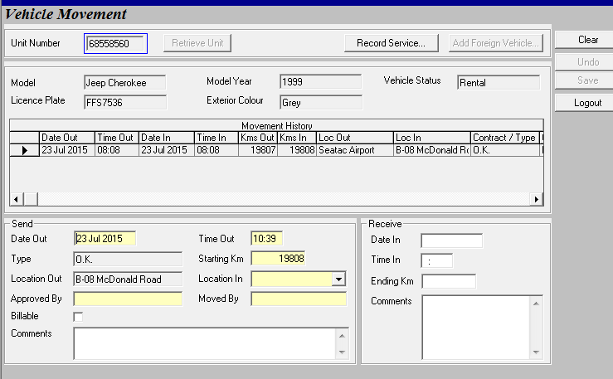

Inter office rental agreement and all relating documents to "Foreign Car Control"

If the OS/Claim vehicle is at hand this vehicle must be add to the fleet under **Add foreign vehicle screen.** When adding theforeign vehicle it is imports that under **Current Location** please select the renting location and for the **Current KM** please use the outgoing Km from original agreement

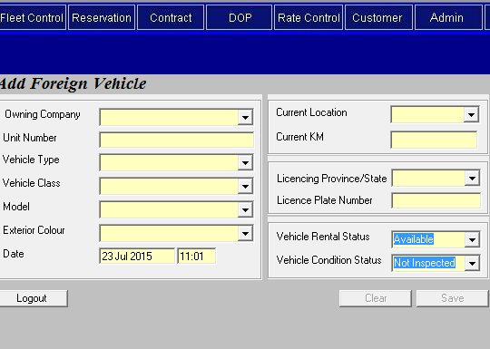

Once vehicle has been created, using the **Vehicle Movement Screen** please send and receive vehicle from the renting location to your location it is import to out under the Comments Rental agreement number, the replacement vehicle unit or mva number and reason for vehicle switch.

1. 2nd scenario:

**New Rental Agreement:** If the replacement vehicle is owned by a different operator then the renting city the assisting city (Brac BC) will open a **new rental agreement as a walk-up.** The original rental agreement will remain open and the new rental agreement will be billed direct billed to Inter-branch. If PO number has been provided please insert PO number and under internal comment please put in the reason for the vehicle exchange, agreement number and distribution agent who approved the exchange.

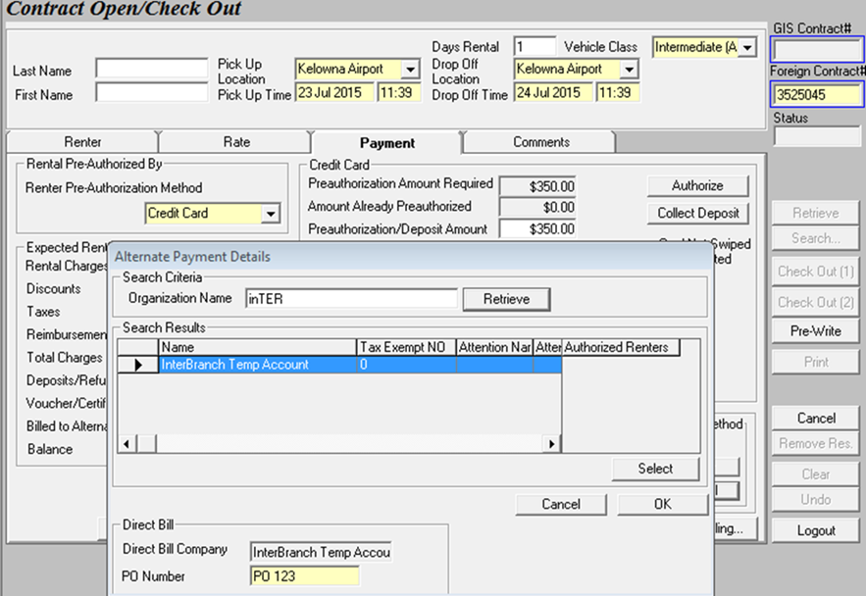

Again if OS/Claim vehicle is at hand this vehicle must be add to the fleet under **Add foreign vehicle** screen. Please see 1st scenario to for step by step instruction.

**NOTE** Staple the " Foreign City RA + GIS Open and Close out" as one complete transaction and give to the Inter-branch dept.

**Brac BC Vehicle Switch**

Foreign city vehicle switchs can only be approved by Brac BC vehicle support department; approval will be indicated in the comments of the rental agreement and foreign control will be notified by vehicle support via email.

There are 2 different scenarios when handling a foreign vehicle exchange:

1. 1st scenario:

**Brac BC Vehicle** : if the replacement vehicle is also owned by Brac BC, then the assisting city will email a replacement contact ( based on Budget BC RA) indicating the following:

1. Date and time of switch
2. Replacement vehicle unit or mva number
3. License plate number
4. Km out

The assisting foreign city will so provide a close contract for the OS/Claim vehicle that is being replaced if they have the vehicle on hand. The close contract will indicate the following

1. Date and time of check in
2. vehicle unit or mva number
3. License plate number
4. Km in for the OS/Claim vehicle if on hand
5. Fuel level for the OS/Claim vehicle if on hand

To enter switch by accessing the Changes During Rental screen and calling up the contract.

**To Check in before Switching a Vehicle**

1. Load the contract into the Contract Changes During Rental screen.
2. Enter the Change Location (The default is the current location.)
3. Go to the Check In Vehicle section of the Replace Vehicle tab and click Replace Vehicle. The Check In fields becomes active.
4. The Check In Time field shows the current date and time. Confirm or replace this value. This value cannot be a future date or time. (The check in date and information will be on the close contact provided by the foreign assisting city other wise use the check-out date and time.)
5. Enter the current kilometer reading into the Km In field. (If the vehicle is not on hand put in 1 km above outgoing km and indicate in comments vehicle not in hand and current location of vehicle.)
6. Enter the Reason the vehicle is being checked in.
7. Select the Condition of the vehicle.
8. Enter the Fuel Information.

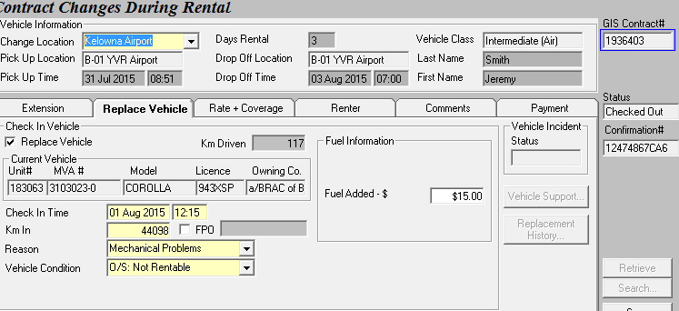

**NOTE:** Budget does not permit more than two vehicle switches on a single contract (for a total of three vehicles). You can review the list of vehicles associated with the contract by clicking Replacement History. This button is disabled if no history exists.

**To Replace a Vehicle**

1. In the Replacement Check Out Vehicle section, select a new Vehicle Class if required.
2. If an upgrade is indicated on the original open enter the daily upgrade charge or enter 0 in the Upgrade Charge field.
3. Enter the Unit # and License and click Get Vehicle. (If the replacement vehicle is not right locations please move in GIS to the correct location. If new location is over 80Km from the check location please investigates how the vehicle got to the renting location.)
4. If the customer purchased the Fuel Purchase Option select FPO.

**NOTE** Once an FPO is purchased, it cannot be removed from the contract. If the customer switches vehicles, the FPO is prorated based on the size of the new vehicle’s fuel tank, and applies to the new vehicle as well. For more information about the FPO, see GIS help desk.

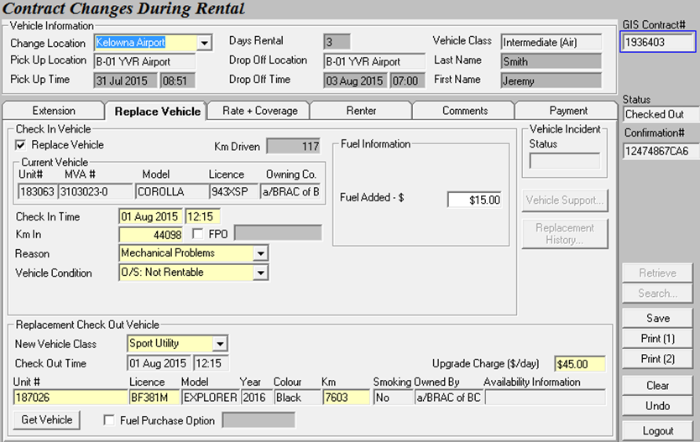

1. In the comments section enter the assisting foreign city replacement contact

2. 2nd scenario:

**Foreign Vehicle:** if the replacement vehicle is owned then the assisting city or another franchise the assisting city follow the same steps as in scenario 1 providing the same documentation. To enter switch follow the same step by step procedure as scenario 1 but the extra step of Add foreign under the **Add foreign vehicle screen** before you can replace the vehicle. Please see Page 1.